I Am Trash

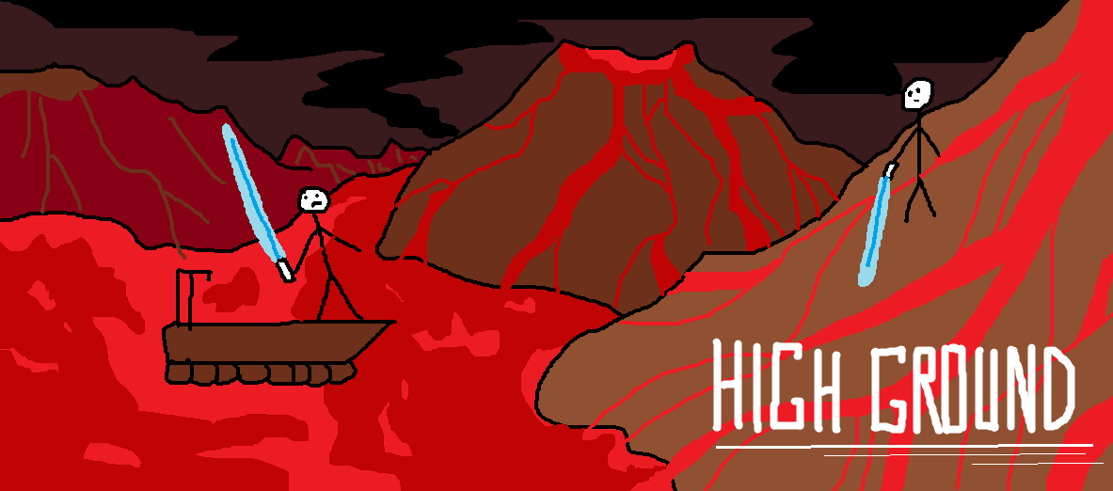

Revision: 0.0.0

GDD Template Written by: Benjamin “HeadClot” Stanley

License

If you use this in any of your games. Give credit in the GDD (this document) to Alec Markarian and Benjamin Stanley. We did work so you don’t have to.

Feel free to Modify, redistribute but **not sell** this document.

TL;DR - Keep the credits section of this document intact and we are good and do not sell it.

Overview

Theme / Setting / Genre

Core Gameplay Mechanics Brief

Targeted platforms

Project Scope

Influences (Brief)

- Arcade Games

- Pacman

The Elevator Pitch

Project Description (Brief):

What sets this project apart?

Core Gameplay Mechanics (Detailed)

- Stealth Mechanics

- Resource Management

Story and Gameplay

Story

Gameplay (Brief)

Gameplay (Detailed)

Assets Needed

- 2D

- Sound

- Code

- Animation

Schedule

- Sprint 1 (3 Weeks)

- Sprint 2 (3 Weeks)

- Sprint 3 (3 weeks)

- Spring Semester

# Overview

## Theme / Setting / Genre

- Arcade Maze

## Core Gameplay Mechanics Brief

- Timed play

- Token collection

- Enemy chaser

## Targeted platforms

- PC

- HGD Arcade Cabinet

## Project Scope

- Game Time Scale

- Two Semesters

- Team Size

- Team Highground

- Evan Overweg

- Team Lead

- Game Developer

- Abri Ingrassia

- Artist

- Jared Perttunen

- Game Developer

- Kevin Cornell

- Game Developer

- Robin Kerr

- Game Developer

- Drew Stockero

- Sound Team Member

## Influences (Brief)

### - Arcade Games

The mechanics of arcade games, including fast-paced levels, increasing difficulty, and simple controls influenced the format of our game.

### - Pacman

The very basic mechanic of collecting multiple items for points while avoiding enemies is heavily from Pacman. We’ve changed the tempo by adding stealth and resource management mechanics to our game.

## The Elevator Pitch

An arcade-style game of garbage collection, challenging the player to collect all the items on the screen in the time given while avoiding wildlife intent on getting it themselves.

## Project Description (Brief):

The player controls a sentient trash can that moves throughout the level. The level(s) will be designed to look like city streets that contain a variety of trash collectables. The player’s goal is to collect all of the trash in the level in a certain amount of time. In order to achieve this goal, the player must move through the level collecting trash. As the player accumulates trash, they will become slower/smellier. Depositing your trash in designated dumpsters will get rid of this penalty.

Inhabiting the levels will be raccoons that are trying to eat the trash you collect. The level(s) will contain a certain amount of raccoons to make the level more challenging to the player. The raccoons will not always be able to detect the player as they move through the level. The raccoons will be able to detect the player based on the amount of trash they are carrying and attempt to get at the player’s trash.

# 

# What sets this project apart?

- More depth to stealth mechanics

- Detailed maps for multiple levels

- Resource management in the form of trash

## Core Gameplay Mechanics (Detailed)

### - Stealth Mechanics

- Raccoons wander the map aimlessly, but if the player moves to close to the animals they will be chased. If the animal catches the player, all their trash is removed and they have to collect from scratch. To prevent this the player must sneak around the animals and avoid aggro, but everytime they collect trash they become smellier and attract animals easier. If the player is caught by an animal, the animal will remove all their trash and scatter it across the map.

- A radiant AI script will make the animals move around the map seemingly aimlessly. The animals will have an area or cone around them that symbolizes their sense of smell. The player will have a circle around them that symbolizes how smelly they are. When the animal’s and player’s cones overlap, aggro is triggered and a chase script is activated for the animal. The animal will then chase the player until the player is either caught or escapes a sufficient distance away.

### - Resource Management

- The main resource the player will have to manage is how much trash they are collecting. Obviously the more trash they can collect the more points they will earn. However, the downside to having more trash in their inventory is that they move slower and attract animals more easily. The player has the option to deliver/dump their trash in dumpsters scattered around the map, this takes time though. This will empty their inventory allowing them to continue collecting trash, but it will cost them time to keep doubling back.

- A basic script that tracks when trash is collected and adding to an integer value which dictates the speed and “smell” of the player. That script will set the integer back to its base value once the player reaches a dumpster or is attacked by an animal.

**- Point Based Level Progression**

- Progression in the game will be based on how much trash the player can manage to gather in a given level. A minimum amount is required in order to progress to the next level. If the player fails to collect the minimum amount in time, they will have to try again. Players can try and reach higher and higher scores by replaying levels. In later versions of the game we can reward players for earning high scores with cosmetics or easter eggs.

- A back end script that only allows a player to progress to the next level once their stored high score on the previous level reaches the necessary threshold. Similarly we may use the same script to hide and unlock rewards for reaching very high scores.

# Story and Gameplay

## Story

The player is a sentient garbage can collecting garbage in the night, with raccoons trying to catch up and get into the bag.

## Gameplay (Brief)

Top-down play with four-directional control and automatic trash pickup and dropoff.

## Gameplay (Detailed)

The player views the level from above, the entire level fits on the screen and the player can see the whole level from the start. The player can control the trash can to move in one of four directions at a time, up, down, right, and left. The trash can moves while the player is holding the corresponding key/pushing the joystick and does not move if the player is not. The player moves the trash can over pieces of trash, which are collected automatically and added to the trash bag. The player can then move the trash can in front of the dumpster, where the current trash bag is dumped automatically into the dumpster and the collected trash is added to the current score.

There is a level timer that counts down from a set amount per level. If the level timer reaches zero before the player has collected and dumped all the trash, the level ends and the player loses. If the player collects all the trash before this time, when the last of the trash is deposited into the dumpster the player wins the level and can move to the next.

# 

# Assets Needed

## - 2D

- Background Textures

- Buildings

- Roads

- Sidewalks

- Alleyways

- Sprites

- Trash Can

- Raccoons

- Dumpster

- Trash (multiple)

## - Sound

- Sound List (Ambient)

- Map Themes

- Two versions of a single 16-bit stylized theme, one calmer theme for when animals are not aggroed, and a more tense theme for when animals are aggroed. Same melody, but change instruments and tempo.

- Sound List (Player)

- Character Movement Sound List

- Some sort of boop sound for player movement

- Trash Pickup

- Raccoon Sounds

## - Code

- Character Scripts (Player Pawn/Player Controller)

- Player character movement

- Trash collection

- Trash deposit into dumpster

- Ambient Scripts (Runs in the background)

- Game manager

- NPC Scripts

- Raccoon movement

- Raccoon scattering trash

## - Animation

- Environment Animations

- Moving silhouettes in building windows

- Smoke from chimneys or vents

- Character Animations

- Player

- Idle animation, Moving animation - trash can lid will open and close slightly

- Possibly an animation for picking up trash

- NPC

- Raccoon running

- Raccoon stealing trash

# 

# Schedule

### - Sprint 1 (3 Weeks)

- Player Movement

- A working level

### - Sprint 2 (3 Weeks)

- Scoring (Trash Collection)

- Time Limit

### - Sprint 3 (3 weeks)

- Enemy AI/NPC (Raccoons)

- Polish Level(s)

### - Spring Semester

- Additional Levels

- Additional Enemies